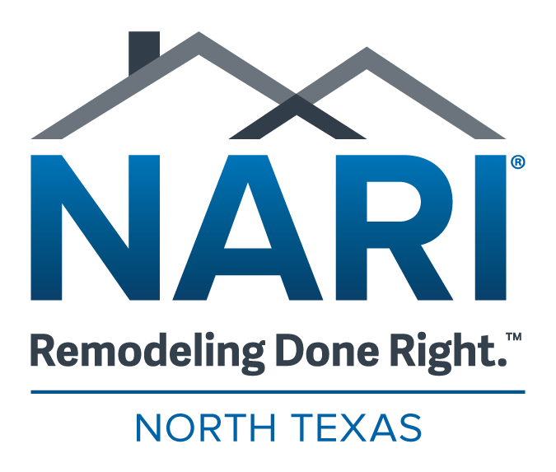

Community Service Award Nomination Form

The Community Service Award may be presented to a NARI North Texas member for remodeling work completed on a charitable basis and/or other forms of community service, including but not limited to, serving on councils, boards, etc. of local municipalities.

Any entry whose use of the NARI logo, certification designation, CotY or any other NARI logo that does not comply with usage rules and criteria as set forth by NARI Headquarters will not be eligible.

Eligible Nominees: NARI North Texas Members

Eligible to Nominate: NARI North Texas Member Company or NARI North Texas Member Company Individual

Person to be Nominated: _______________________________________________

Person/Company making Nomination: ____________________________________

Your Contact Information: ______________________________________________

Why do you feel this person deserves to be recognized for the Community Service Award? _______________________________________________________
______________________________________________________________________
______________________________________________________________________
______________________________________________________________________
______________________________________________________________________

The deadline to receive nominations is stated on the website.

Send nominations via email to jennifer@narintx.org with

Community Service Award in the subject line.

